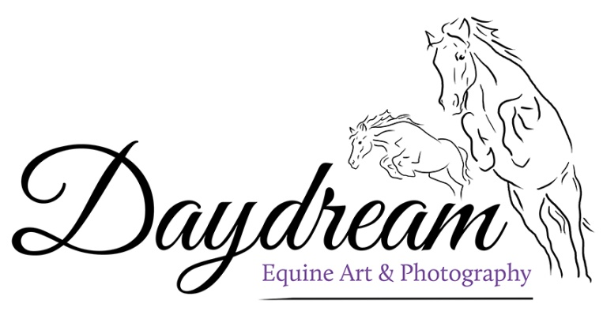

Order Form

Please feel free to add in more rows to the table, or copy this format in to an email to order. Once I have received your order form I will send you an invoice. Fill in the relevant tables dependant on your order.

**Please email your form to:** [**daydreamequine@gmail.com**](mailto:daydreamequine@gmail.com)

**Postal Address (where applicable):**

**Recipient Name:**

**House Name/Number:**

**Street Name:**

**Postcode:**

**Contact Number:**

**Space For Any Alterations To Images/ Other Requests:**

**A La Carte Ordering:**

|  |  |  |  |
| --- | --- | --- | --- |
| Product | Image Number | Size | Quantity |
|  |  |  |  |
|  |  |  |  |
|  |  |  |  |
|  |  |  |  |
|  |  |  |  |

**Photobook Ordering: (Delete As Applicable)**

Please use the spaces below to list the images for the book, typically it is one image per page, although I can usually squeeze a few extras in. So, that’s 30 photoss for a 30 page book, or 50 for a 50 page book. Images can be repeated on covers, or completely new ones – each design is bespoke! Place the images in any order and I will fit them together best during the design process.

|  |  |
| --- | --- |
|  | Image Number: |
| 31 |  |
| 32 |  |
| 33 |  |
| 34 |  |
| 35 |  |
| 36 |  |
| 37 |  |
| 38 |  |
| 39 |  |
| 10 |  |
| 41 |  |
| 42 |  |
| 43 |  |
| 44 |  |
| 45 |  |
| 46 |  |
| 47 |  |
| 48 |  |
| 49 |  |
| 50 |  |

**Photobook Size:** 19x9 / Classic A4

**Paper Finish:** Matte / Gloss

**Number Of Pages:** 30 / 50

**Front Cover Image Number:**

**Back Cover Image Number:**

**Wording On Spine:**

**Wording On Front Cover:**

**Wording On Back Cover:**

|  |  |
| --- | --- |
|  | Image Number: |
| 1 |  |
| 2 |  |
| 3 |  |
| 4 |  |
| 5 |  |
| 6 |  |
| 7 |  |
| 8 |  |
| 9 |  |
| 10 |  |
| 11 |  |
| 12 |  |
| 13 |  |
| 14 |  |
| 15 |  |
| 16 |  |
| 17 |  |
| 18 |  |
| 19 |  |
| 20 |  |
| 21 |  |
| 22 |  |
| 23 |  |
| 24 |  |
| 25 |  |
| 26 |  |
| 27 |  |
| 28 |  |
| 29 |  |
| 30 |  |

​

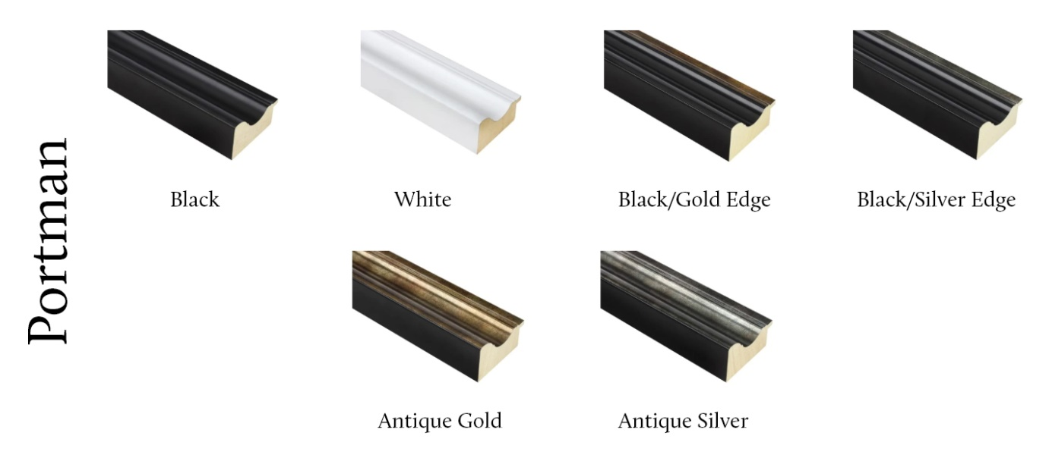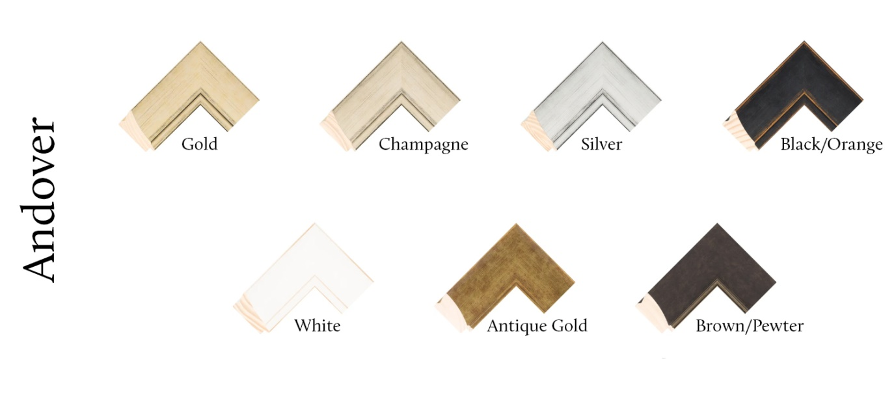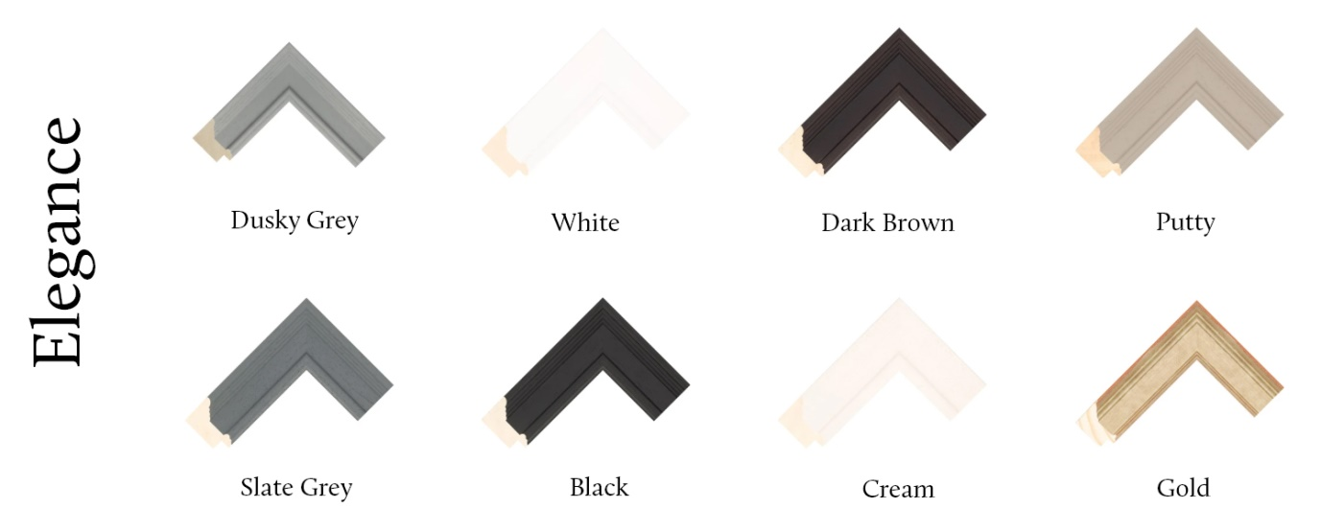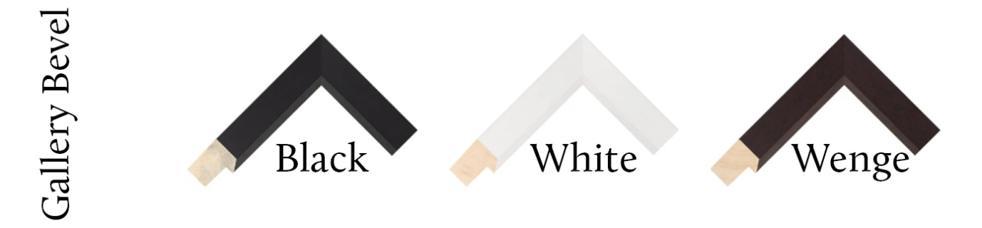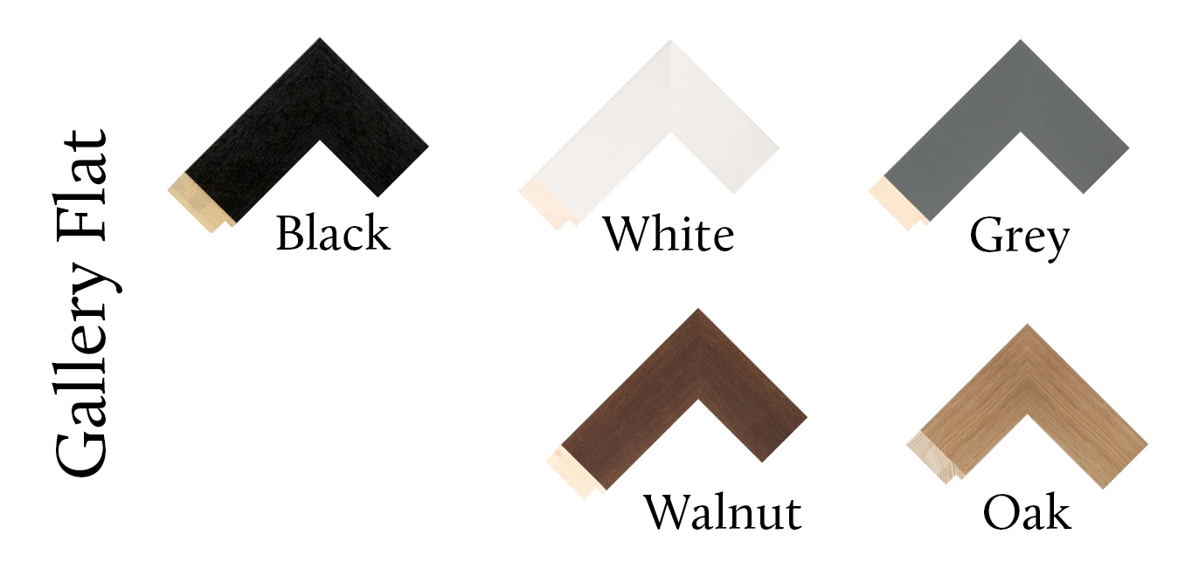

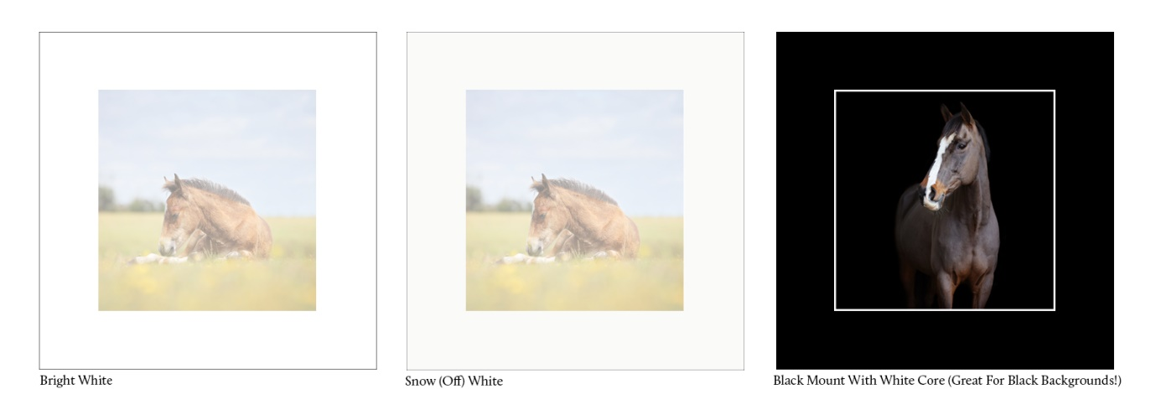**Mount Options:**

Proof/Design Mock Ups of the framing options with your chosen images will be sent prior to the items being printed.

**Multi-Aperture Options:**

I will send a proof before printing to ensure you are happy, or if an amendment needs to take place for the best results. Please select one or the other, either the three image option, or four image layout.

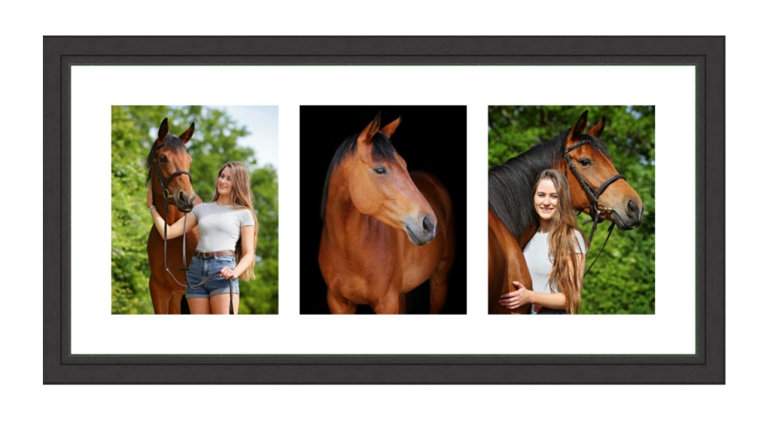

For the 14x30 inch frame, please select three images, either all landscape, or all portrait.

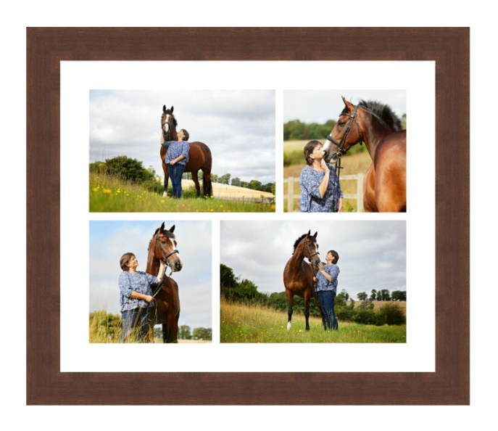

For the 24x20 inch frame, please select two landscape, and two portrait images.

**Client’s Favourite Bundles:**

**Portrait Shoot Bundle:**

* USB Of All Images
* 2 x 20x16 Inch Frames
* 1 x  Multi-Aperture **20x24 OR 14x30** Inch Frame
* + 10% Off Any Extra Items Ordered From The A La Carte Options

|  |  |  |  |
| --- | --- | --- | --- |
| Frame | Image Number/s | Mould Type | Mount Colour |
| 16x20 (Single Image) |  |  |  |
| 16x20 (Single Image |  |  |  |
| 20x20 (Multi-Aperture) | A/B/C/D: |  |  |

**Black Background Shoot Bundle:**

* 5 x Images on USB
* 1 x 20x16 Inch Frame
* + 10% Off Any Extra Items Ordered From The A La Carte Options

Proof/Design Mock Ups of the framing options with your chosen images will be sent prior to the items being printed.

|  |  |  |  |
| --- | --- | --- | --- |
| Frame | Image Number/s | Mould Type | Mount Colour |
| 16x20 (Single Image) |  |  |  |